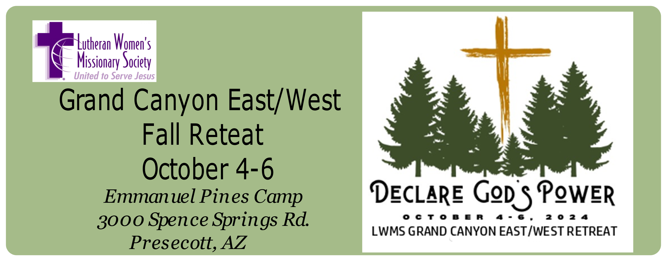
Online payment and registration available at grandcanyonlwms.org/retreat/

The retreat fee includes 2 nights of lodging, 2 breakfasts, one lunch, and 2 dinners. Bring bed sheets, pillow, towels and toiletries.
Check-in begins at 3:00 pm.

Name: ______________________________________________________________
Address: ____________________________________________________________
______________________________________________________________
Phone: ______________________________________________________
email: _______________________________________________________
Home Congregation: _________________________________________________
City, State _________________________________________________________
Registration Fee:_______________ Retreat Working Fund: _______________
If possible, please donate toward our LWMS circuit board's working fund.
These funds will be used to help defray costs related to our 2024 Fall retreat.
If more funds are collected than required, the additional fund will be given to the chosen freewill offering project.

Check Amount Paid: _______________________________
Each of the bunk rooms sleeps 6-8 people. If you have a special request for roommate(s) please list their names below.
________________________________________________________________
________________________________________________________________

Allergies/Food restrictions: ________________________________________
Mail registration to: Barb Mork
13519 N. Garlenda Way
Oro Valley, AZ 85755

